Deployment Steps

1. EC2 Setup
- Launched Ubuntu EC2
- Opened ports 22, 80

2. Backend Setup
- Installed Node.js
- Configured MongoDB Atlas
- Started using PM2

3. Frontend Setup
- Updated API URL
- Created production build
- Served with Nginx

4. Load Balancer
- Created Target Group
- Registered EC2 instances
- Configured health checks

5. Cloudflare Tunnel
- Installed cloudflared
- Exposed app via HTTPS public URL

Screenshots

AWS
- EC2 → showing 2 instances running

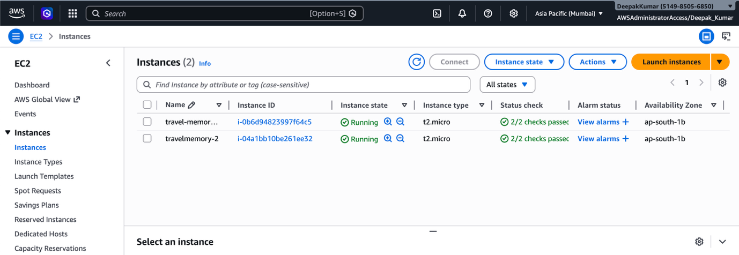

- Target Group → 2 healthy

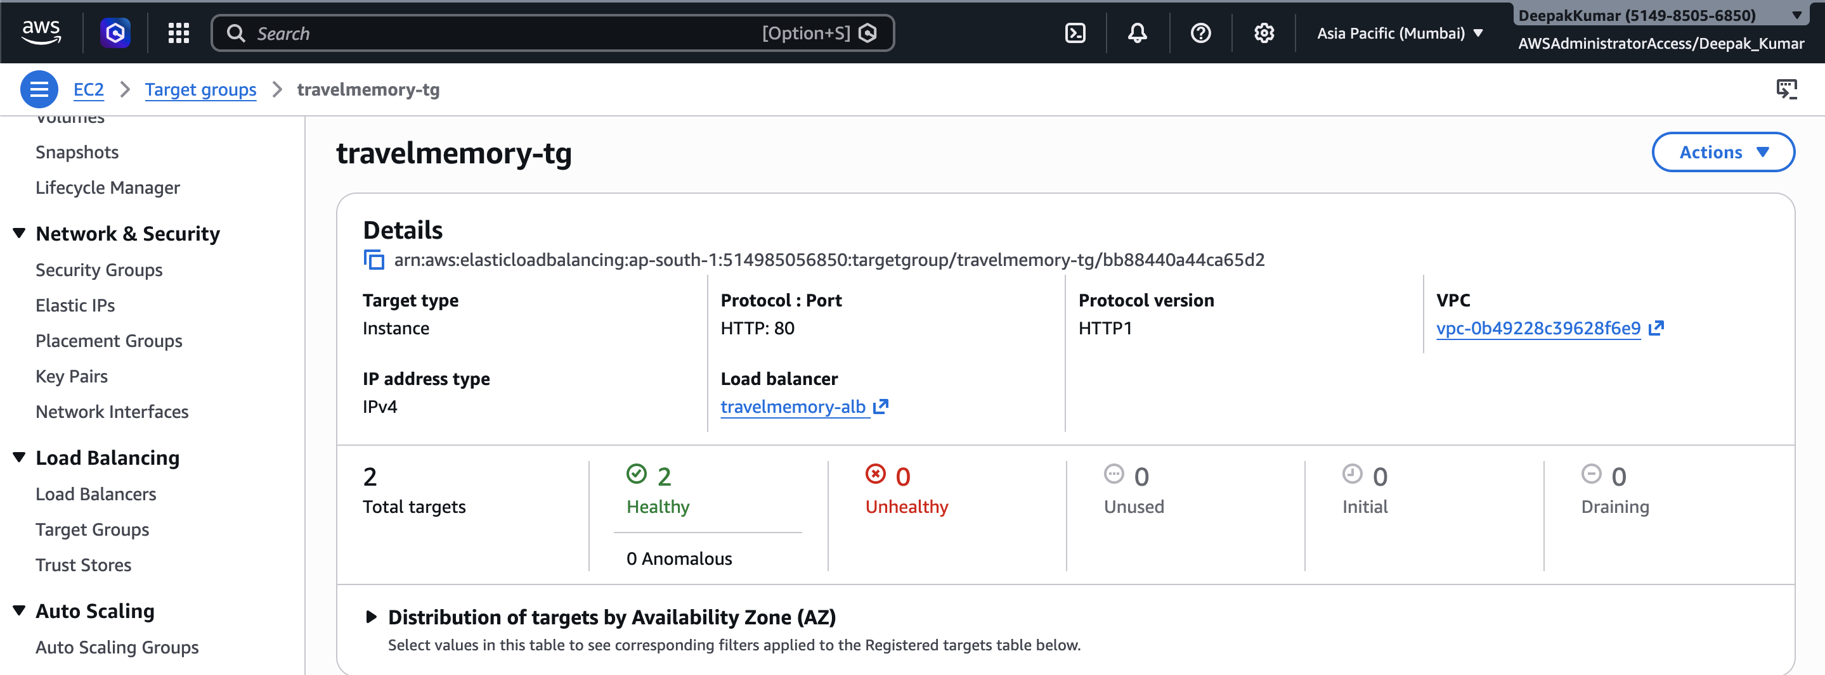

- Load Balancer → listeners

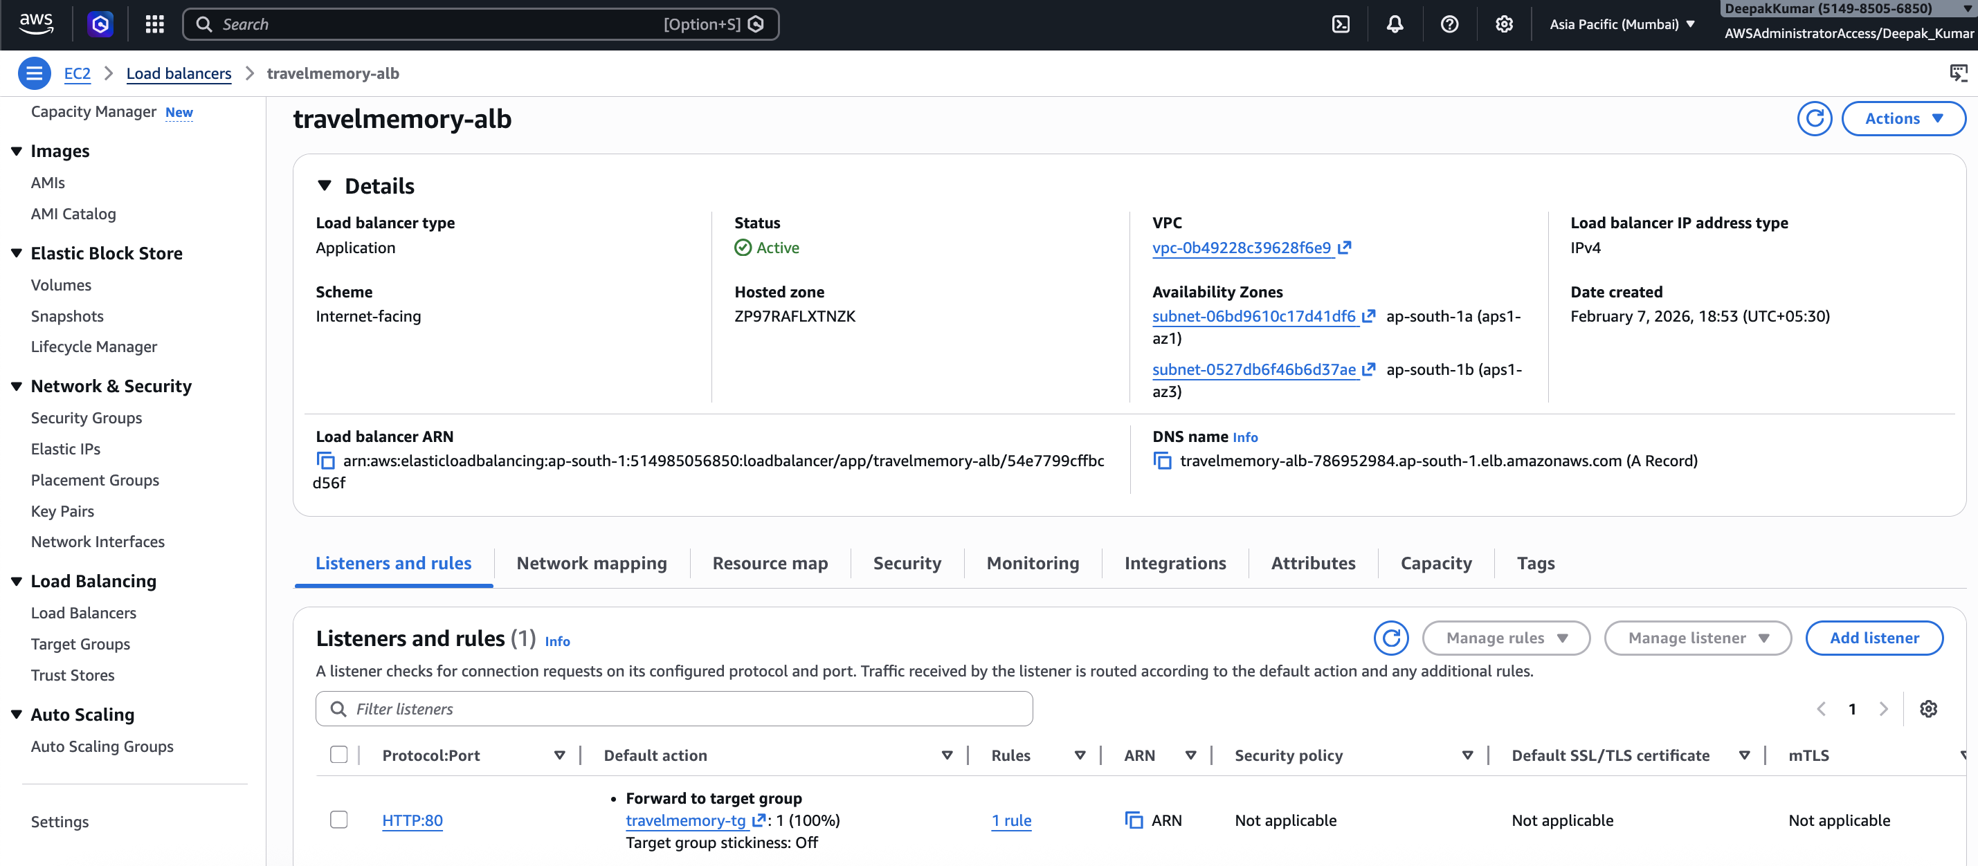
- Security group → ports 22 & 80

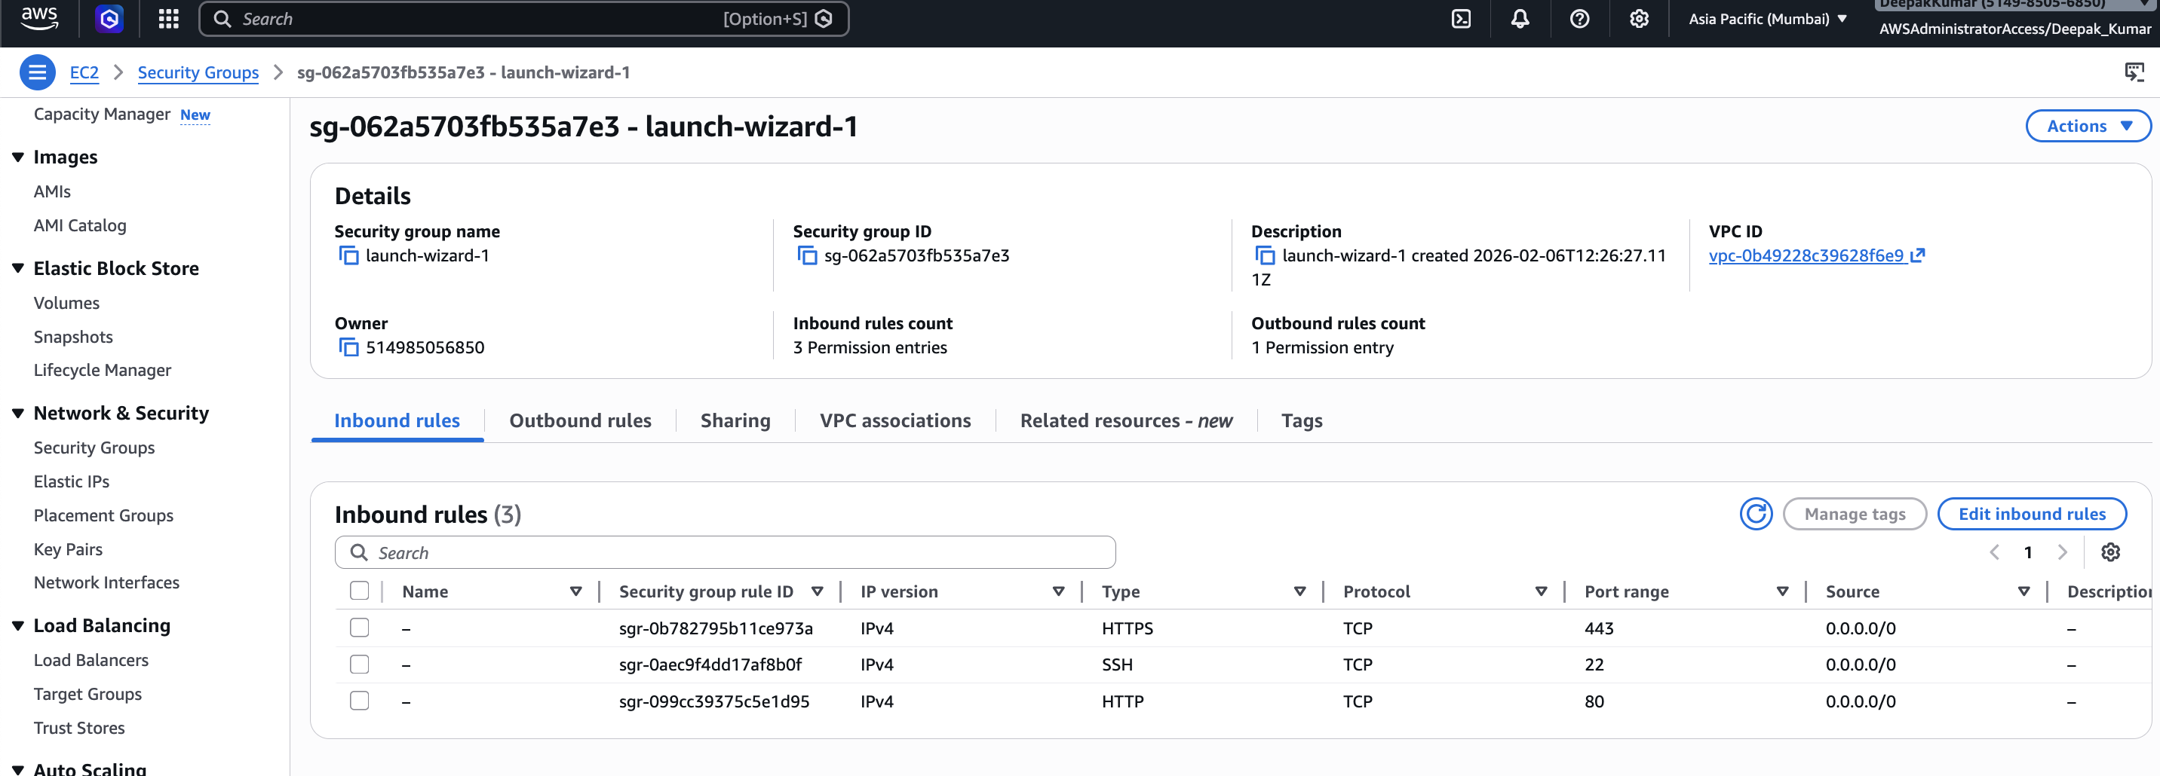

SERVER

- pm2 status
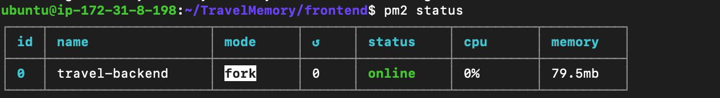
- Nginx config file

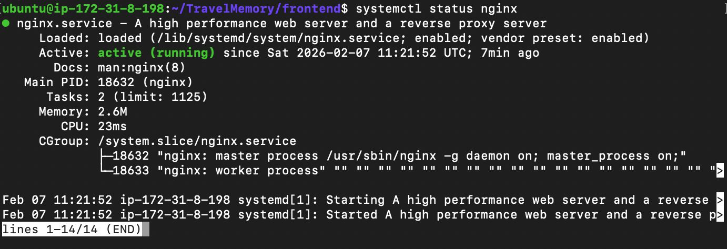

- MongoDB Atlas connected
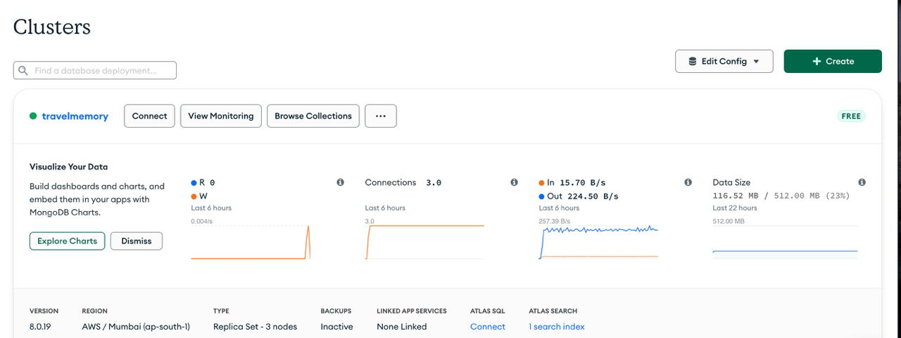

App
- ALB DNS working in browser

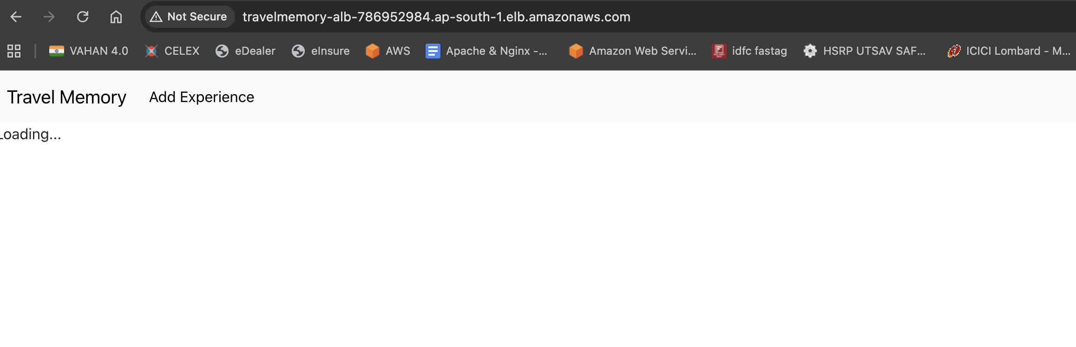

- Cloudflare URL with 🔒 HTTPS

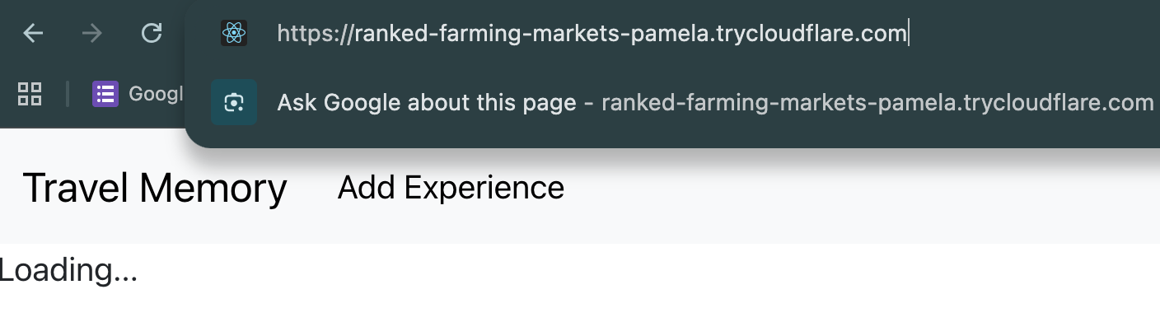

- cloudflared tunnel running in terminal

